WALLER COUNTY COURT AT LAW NUMBER TWO
NOTIFICATION OF OPPORTUNITY AND APPLICATION FOR MISDEMEANOR/LIMITED FELONY
CRIMINAL APPOINTMENTS FOR FLUENT SPANISH-SPEAKING ATTORNEY

Indigent Defense Attorney Contract for CRIMINAL Appointments (SPANISH LANGUAGE FLUENCY REQUIRED)
July 1, 2026 through December 31, 202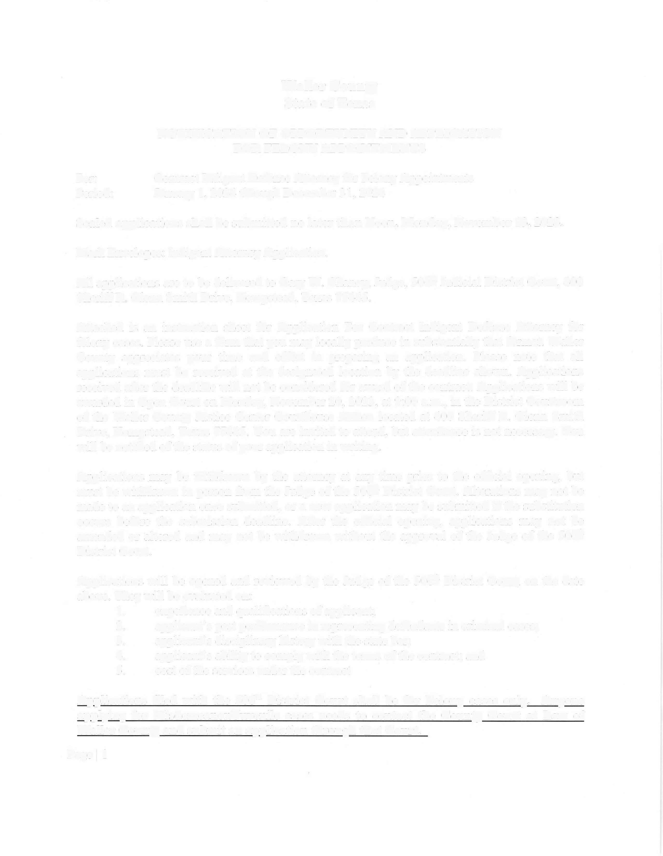6

Sealed applications shall be submitted no later than noon, JUNE 17, 2026.

Mark Envelopes: Indigent Attorney Application.

All applications are to be delivered to Elton R. Mathis, Judge of Waller County Court at Law #2 at 400 Sheriff R. Glenn Smith Drive Hempstead, Texas 77445 or to his staff.

Beginning January 1, 2025, misdemeanor criminal cases of Waller County are heard by the Waller County Court at Law #2, and some lower-level felony cases were transferred to/filed in Waller County Court at Law #2 pursuant to agreements between the Judges of the 506th Judicial District Court and Waller County Court at Law #2.

Attached is an instruction sheet for Application for Contract Indigent Defense Attorney for criminal cases. Please use a form that you may locally produce in substantially that format. Waller County appreciates your time and effort in preparing an application. Please note that all applications must be received at the designated location by the deadline shown. Applications received after the deadline will not be considered for award of the contract. Applications will be awarded in open court on June 17, 2026 at 1:30 p.m., in the courtroom of the County Court at Law #2 at the address referenced above. You are invited to attend, but attendance is not necessary. You will be notified of the status of your application in writing.

Applications may be withdrawn by the attorney at any time prior to the official opening, but must be withdrawn in person from the Judge of Waller County Court at Law #2. Alterations may not be made to an application once submitted. However, a new application may be submitted if the substitution occurs before the submission deadline. After the official opening, applications may not be amended or altered and may not be withdrawn without the approval of the Judge.

Applications will be opened and reviewed by the Judge of Waller County Court at Law Number #2, on and after June 17, 2026 at 12:01 p.m. They will be evaluated on:

1. experience and qualifications of applicant;
2. applicant's past performance in representing defendants in criminal cases;
3. applicant's disciplinary history with the state bar;
4. applicant's ability to comply with the terms of the contract; and
5. cost of the services under the contract
6. FLUENCY OF THE APPLICANT IN SPEAKING SPANISH AND ENGLISH IS OF HIGHEST PRIORITY

Applications filed with Judge Mathis will be for WCC@L2 primarily handling misdemeanor cases and some lower-level felony cases. There may be occasion when by law/local rules, or by agreement between the judges that some higher-level felony cases are assigned to WCC@L2 in accordance with its blended misdemeanor/felony jurisdiction.

Capital Murder cases, whether or not the death penalty is sought, will not be handled under the contract. Appeals and other post-conviction remedies are not included under the contract. Those cases will be appointed by the trial judges as they arise. Other matters requiring special expertise or extensive forensic training may be assigned outside the contract.

Any misdemeanor cases which MUST by law be heard in a district court will be handled under the contract by attorneys assigned to the 506th Judicial District Court.

Applications shall address the matters listed in the Application instructions, experience and costs of services along with any other relevant information.

Attorneys awarded a contract must have access to an office equipped with modern technology and the Attorney must be willing to work with the District Attorney’s assigned employees on assigned cases. As a condition of contract award, attorneys are expected to make contact with assigned clients within 72 hours of their appointment, either at the jail, in person, or in writing. In addition, attorneys will be required to coordinate office visits with the District Attorney's office to discuss trial preparation and discovery compliance.

Attorneys must meet the minimum attorney qualification requirements of the local indigent defense plan for felony cases, and as set out in the Sample Contract available through the Judge’s office. Thereafter, the attorney must constantly:

1. Be a member in good standing with the State Bar of Texas;
2. Professionally perform duties and responsibilities of a licensed attorney for the
State of Texas;
3. Complete annually such Continuing Legal Education programs as required by the
Texas Judicial Counsel and the Waller County District Court Plan filed with the Texas Indigent Defense Commission for attorneys representing indigent accused persons, which shall include at least 6 hours of Continuing Legal Education in handling criminal cases.

A Sample Contract is available for your review and can be emailed directly to you on request. TOTAL COMPENSATION UNDER THE CONTRACT WILL BE $35,000.00 PAID OVER A 6 MONTH PERIOD IN ACCORANCE WITH THE OFFICIAL PAYMENT POLICIES OF THE WALLER COUNTY COMMISSIONERS COURT/AUDITOR/COUNTY TREASURER. Please contact the Judge of Waller County Court at Law #2 with any questions.

